Heir in the Air Activity – Picture Captions

Instructions: Listen to the news clip and write captions to the following pictures:

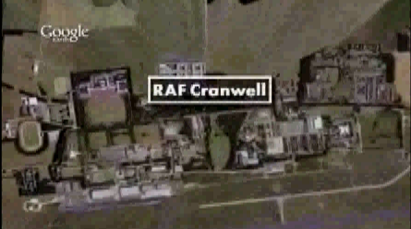  Caption: __________________________ | 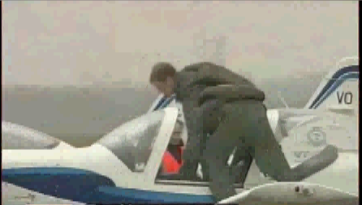  Caption: _________________________
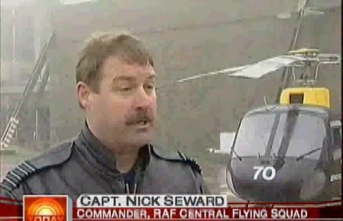  Caption: _________________________ | 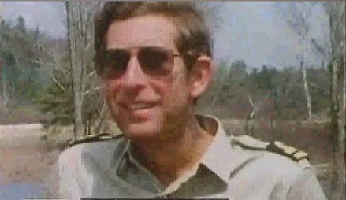  Caption: _________________________

